**Assignment 1 (6p)**

**1. Setting Up C Programming Environment on Linux**

**A. Install the GCC Compiler**

Most Linux distributions come with the GCC (GNU Compiler Collection) pre-installed. To check if GCC is installed, run:

- gcc --version

If it's not installed, install it using:

Ubuntu/Debian:

- sudo apt update

- sudo apt install gcc

Once installed, verify by running:

- gcc --version

Since we already have installed gcc compiler we do not need to install the compiler again.

[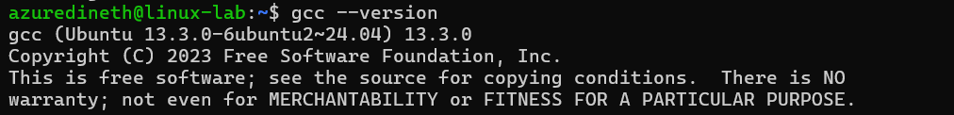](https://github.com/Rashmika-Dineth/Linux/blob/main/Assignment%20C/Images/1.png)

**B. Make a small C program "mycalc.c" to ask user 2 numbers, and print the sum**

1. For ease of use I created a directory called calculator and Im gonna use this folder to write my c program.

[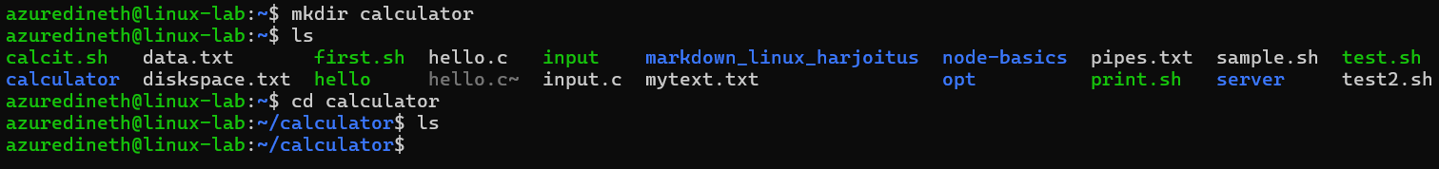](https://github.com/Rashmika-Dineth/Linux/blob/main/Assignment%20C/Images/2.png)

1. Create mycalc.c using nano editor.

[](https://github.com/Rashmika-Dineth/Linux/blob/main/Assignment%20C/Images/3.png)

1. Inorder to check our env & other setting, first try to run Hello world app,
   * Update the file
   * Save the file (Ctrl + s)
   * Exit from nano editor (Ctrl + x)

](https://github.com/Rashmika-Dineth/Linux/blob/main/Assignment%20C/Images/4.png)

1. Compile the file and make mycalc program. (-o mycalc : Output will be mycalc)
   * gcc mycalc.c -o mycalc
2. Now Run the app and check if its working with no issues.

](https://github.com/Rashmika-Dineth/Linux/blob/main/Assignment%20C/Images/5.png)

1. Now we can modify to add our calculator codes.

](https://github.com/Rashmika-Dineth/Linux/blob/main/Assignment%20C/Images/6.png)

1. Compile and run the program

](https://github.com/Rashmika-Dineth/Linux/blob/main/Assignment%20C/Images/7.png)

**2. Part 2 - Setting up node JS server on Linux VM**

1. Make the directory myserver and go inside the folder, get the latest update of apt updates,

](https://github.com/Rashmika-Dineth/Linux/blob/main/Assignment%20C/Images/Part%202/1.png)

1. Install the Node JS and check the version of node and npm, then initiate the node js program,

](https://github.com/Rashmika-Dineth/Linux/blob/main/Assignment%20C/Images/Part%202/2.png)

1. Install the node package express and update the index.js package (After this you can run index.js)

](https://github.com/Rashmika-Dineth/Linux/blob/main/Assignment%20C/Images/Part%202/3.png)

1. Following is the basic code of node js server

](https://github.com/Rashmika-Dineth/Linux/blob/main/Assignment%20C/Images/Part%202/6.png)

1. Update the firewall settings so that the port can be viewed from outside connections,

](https://github.com/Rashmika-Dineth/Linux/blob/main/Assignment%20C/Images/Part%202/4.png)

1. Run the server and check its working with the public ip address and your port id ( '<http://74.234.40.225:3000/>' )

](https://github.com/Rashmika-Dineth/Linux/blob/main/Assignment%20C/Images/Part%202/5.png)

1. If you get the following msg then the server is running with no issues,

](https://github.com/Rashmika-Dineth/Linux/blob/main/Assignment%20C/Images/Part%202/7.png)

1. Update the index.js so the **/user** navigation can display user information by **process.env.USER** [A computer screen with text

   AI-generated content may be incorrect.](https://github.com/Rashmika-Dineth/Linux/blob/main/Assignment%20C/Images/Part%202/8.png)
2. Check the result with **/user** navigation,

](https://github.com/Rashmika-Dineth/Linux/blob/main/Assignment%20C/Images/Part%202/9.png)

**3. Part 3 - Install Python 3, pip, and bpytop on a Linux VM**

1. Get the updated apt list and install python

](https://github.com/Rashmika-Dineth/Linux/blob/main/Assignment%20C/Images/Part%203/1.png)

1. Check the python and pip version. (To make sure setup is success)

[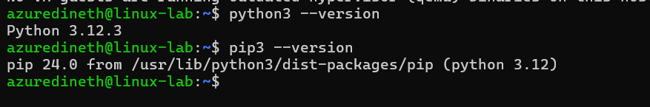](https://github.com/Rashmika-Dineth/Linux/blob/main/Assignment%20C/Images/Part%203/2.png)

1. Install bpytop as a user, (not root user)
   * pip3 install bpytop --user

[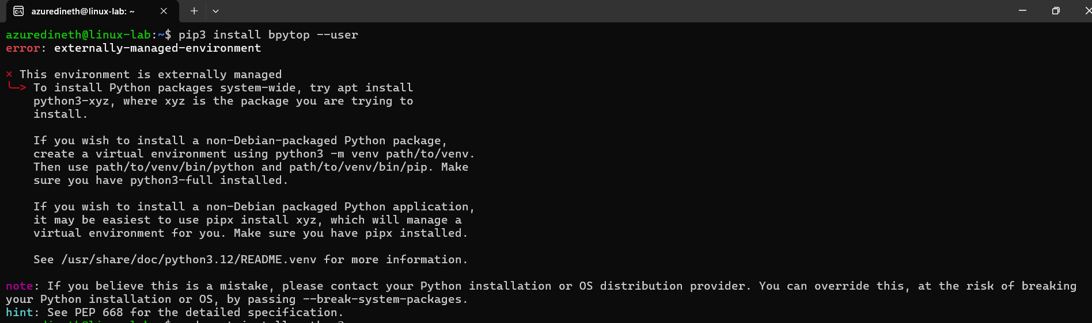](https://github.com/Rashmika-Dineth/Linux/blob/main/Assignment%20C/Images/Part%203/3.png)

Humm!! .. Got an error...

1. Redo using VM inside Linux, (Install the Virtual Environment Package:)
   * sudo apt install python3-venv

](https://github.com/Rashmika-Dineth/Linux/blob/main/Assignment%20C/Images/Part%203/4.png)

1. Create and activate Virtual Environment:

[](https://github.com/Rashmika-Dineth/Linux/blob/main/Assignment%20C/Images/Part%203/5.png)

1. Now install bpytop inside the VM and run it,

](https://github.com/Rashmika-Dineth/Linux/blob/main/Assignment%20C/Images/Part%203/6.png)

1. Take a screenshot of the bpytop

](https://github.com/Rashmika-Dineth/Linux/blob/main/Assignment%20C/Images/Part%203/8.png)